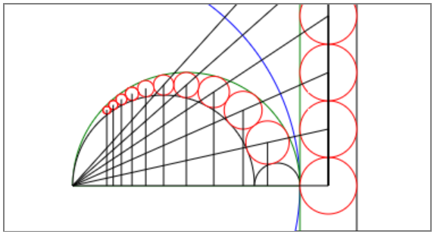

# Circle Inversion & Pappus Chain

Su Kara

Advisor: James G. Wenk

Grade: 8

Newhart Middle School

Mission Viejo, CA

Presented at OCSEF

March 12-14, 2018

# Abstract

Arbelos is the region bounded by three semicircles in the figure below. Diameters of the semicircles are all on the same line,and each one is tangent to the other two. Mathematicians have studied the arbelos since ancient times, which was named for its resemblance to the shape of a round knife used by shoemakers (ScienceBuddies, 2017).

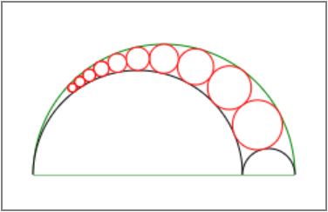

Pappus chain is the chain of circles inscribed in the arbelos. It was called after Pappus of Alexandria, who studied it in the 4th century A.D. Pappus proved a theorem, which states that the height, *hn*, of the center of the *nth* inscribed circle, *On,* above the diameters of the semicircles is equal to *n* times the diameter of *On*, *dn*.

*hn* = *n.dn*

Pappus' proof relied on the Euclidean geometry, and took several pages. The modern proof is much simpler and uses the powerful method of *circle inversion*, invented by Jakob Steiner in the 1820's. My goal is to develop an open-source software application to simulate circle inversion and prove Pappus' theorem.

Table of Contents

Problem 1

Introduction 1

Inversion of a Point 2

Inversion of a Circle 3

Circle Not Passing Through the Center of the Inversion Circle 4

Circle Passing Through the Center of the Inversion Circle 5

Pappus Chain 9

Inversion of a Pappus Chain 10

Homothety 10

Materials & Methods 12

Results 14

Inversion of a Point 14

Inversion of a Circle 15

Pappus Chain 16

Discussion 17

Conclusion 19

Further Research 20

Acknowledgements 20

References 20

# Problem

Prove that the height from the center of the *nth* inscribed circle in the Pappus chain is equal to *n* times the diameter of that circle by using *circle inversion*.

# Introduction

Inversion in a circle is a method to convert geometric figures into other geometric figures (Tom Davis, 2011). This method can be used in many situations to convert difficult problems into simpler ones. It is like reflection across a line:

* Any figure can be reflected across a line or inverted in a circle.
* Reflecting a figure across the same line twice returns it to its original form. The same is true for inversion in a circle.
* Reflection takes points to the other side of the line; inversion takes points to the other side of the circle. In other words, points inside are inverted to the outside and vice-versa.
* There is an easy mathematical relationship between a figure and its reflection or between a figure and its inversion.
* Sometimes it is much easier to work with the reflected version or the inverted version of a figure.

There is a simple way to describe how a point can be inverted in a circle. If we wish to invert a more complex figure than a single point, we simply invert every point in the figure and the resulting set of points becomes the inverted figure.

## Inversion of a Point

Inversion is the process of transforming a point *P* to a corresponding point *P′* known as its inverse point (WolframMathWorld, 2017). Two points *P* and *P′* are said to be inverses with respect to an “inversion circle” having an “inversion center” *O* and “inversion radius” *r* if *P* is the perpendicular foot of the altitude of *OQP′*, where *Q* is a point on the circle such that *OQ*┴*QP′*.

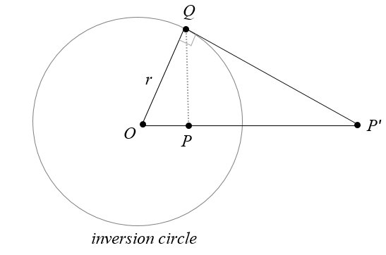

From similar triangles, the following is true for the inverse points *P* and *P′*:

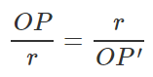

or



where the quantity *r2* is known as the *circle power*.

The general equation for the inverse of a point *(x,y)* relative to an inversion circle with inversion center *(x0,y0)* and inversion radius *r* is given by:

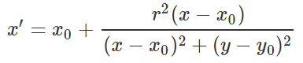

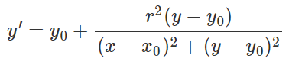

A point on the circumference of the inversion circle is its own inverse point. Since *OP* will be equal to *r*, *OP*′ must be equal to the same to satisfy the equation *OP.OP′=r2*.

The center of an inversion circle cannot be inverted. It is easy to see why there is a problem when we try to invert the point *O*. If we consider points *P* that are very close to *O*, the length *OP* will be tiny, and to satisfy the equation *OP.OP′=r2* will require that the length *OP′* will have to be huge. It’s as if the point *P′* moves infinitely far away along the line.

## Inversion of a Circle

If every point on a circle is inverted with respect to an inversion circle with center *O*, the result will be a circle or a line (Tom Davis, 2011). Some key results of inversion:

* A circle that is completely inside of the inversion circle that does not pass through *O* is inverted to a circle that is completely outside of the inversion circle and vice-versa. A circle that intersects the inversion circle, but doesn’t pass through *O* will invert to a circle that also intersects the inversion circle at the same points.
* A circle that passes through *O* is inverted to a line. If that circle also passes through the inversion circle at two points *P* and *Q*, its inversion will be the line passing through *P* and *Q*. If a circle passes through *O* and is internally tangent to the inversion circle, its inverse will be the line externally tangent to the inversion circle.
* A line that does not pass through *O* is inverted to a circle that passes through *O*.
* A line that passes through *O* is inverted to itself. Note that the individual points of the line are inverted to other points on the line except for the two points where it passes through the inversion circle.
* A circle that is orthogonal to the inversion circle will be inverted onto itself.

Treating lines as circles of infinite radius, all circles invert to circles. The property that inversion transforms circles and lines to circles or lines makes it an extremely important tool of plane analytic geometry. By picking a suitable inversion circle, it is often possible to transform one geometric configuration into another simpler one in which a proof is shown more easily.

### Circle Not Passing Through the Center of the Inversion Circle

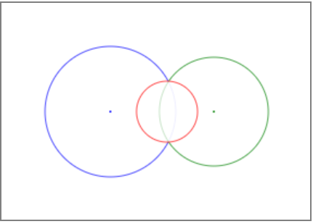

The inverse of a circle (green) of radius *r* with center *(x,y)* with respect to an inversion circle (blue) with inversion center *(x0,y0)* and inversion radius *r0* is another circle (red) with center (WolframMathWorld, 2017):





and radius:



where

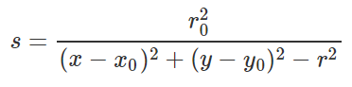

### Circle Passing Through the Center of the Inversion Circle

If a circle passes through the center of the inversion circle, the inversion will be a line rather than a circle. If the circles intersect, the inverted line will pass through the intersection of the two circles (AmBrSoft, 2016).

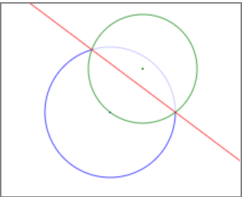

Equations of the two intersecting circles:





Distance between the centers of the two circles:

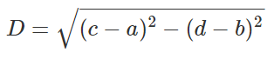

Conditions for intersection between two circles:

 and 

Equation of the line connecting the two intersection points:

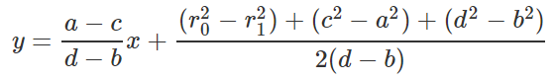

Intersection points of the two circles:



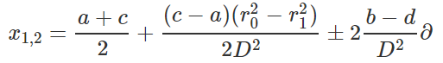

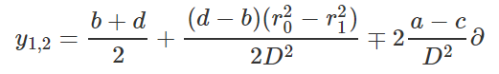

If the circles don’t intersect, the inverted line will be outside the inversion circle. First, you can find the coordinates of the point on the original circle that is one diameter away from the center of the inversion circle. Now invert that point with respect to the inversion circle to find the point that passes through the inverted line. The rest is about finding the slope of the inverted line that must be perpendicular to the diameter of the original circle.

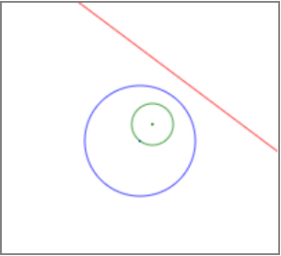

Find the point one diameter away from the inversion center:





Invert that point to find the point on the line:

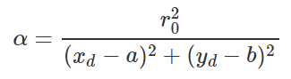





Calculate the slope of the diameter (rise/run):

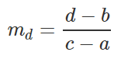

Calculate the slope of the inverted line (perpendicular):

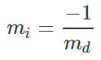

Calculate the intercept of the inverted line (y=mx+b):



Equation of the inverted line:



## Pappus Chain

The area bound by the three semicircles forms an arbelos, and the circles inside the arbelos construct a chain of circles. The red circles in this chain are all tangent to one of the two small interior semicircles and to the large exterior one. This chain is called the Pappus chain (WolframMathWorld, 2017).

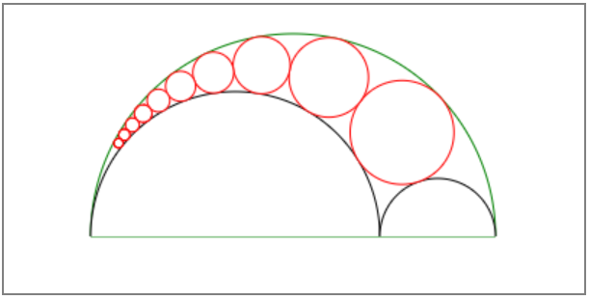

If *r* is the ratio of the radius of the big inner semicircle to the small one, then the center and radius of the *nth* circle in the Pappus chain will be:

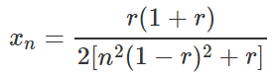

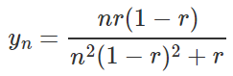

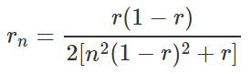

### Inversion of a Pappus Chain

The blue circle in the figure below serves as the inversion circle, and its center is the left corner of the diameter of the semicircles. Inversion maps the two semicircles onto two parallel lines perpendicular to their diameter since they both pass through the center of the inversion circle. The circles in the Pappus chain get inverted to a chain of identical circles inscribed between the two parallel lines (CutTheKnot, 2017). For those identical circles, the height from the center of the inverse circle *n* to the diameter is obviously *n* times its diameter.

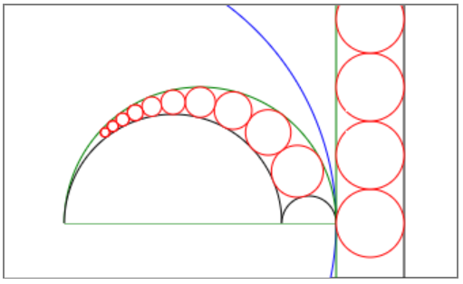

### Homothety

Homothety, also known as dilation or central similarity, is a transformation of Euclidean space with respect to a certain point *O* that brings each point *M* in a one-to-one correspondence with a point *M′* on the straight-line *OM* in accordance with the rule:

*OM′ = k.OM,*

where *k* is a constant number, not equal to zero, which is known as the homothety ratio or dilation factor (EncyclopediaOfMath, 2014). The point *O* is said to be the center of homothety or center of dilation (Charles, R. I., Hall, B., and Kennedy, D., 2015). If *k>0*, the points *M* and *M′* lie on the same ray; if *k<0*, they are on different sides from the center. A homothety is a special case of similarity. Two figures are called homothetic (similar or similarly situated) if each one consists of points obtained from the other figure by a homothety with respect to some center.

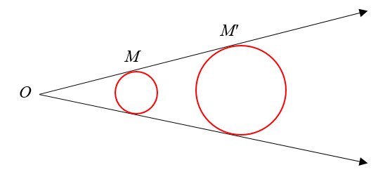

# Materials & Methods

I used a MacBook Pro to develop a web page with the use of HTML5 and JavaScript. I wrote the source code in Brackets, an open-source text editor. This web page serves as a generic tool for circle inversion and Pappus chain. The user can invert a point or a circle with respect to an inversion circle. It can also be used to create a Pappus chain, invert the circles and semicircles, and show homothety between the circles in the Pappus chain, and their inversions.

On a standard coordinate system in math, (0,0) is the bottom-left corner, and the y-coordinate increases as you move up. On the contrary, a computer screen designates the top-left corner as (0,0), and the y-coordinate increases as you move down. Therefore, I converted the y-coordinate in my program by subtracting its value from the canvas height right before drawing a shape. This conversion made the canvas look more consistent with a math coordinate system.

I decided to create a simple user interface where people can easily play with circle inversion and Pappus chain by themselves. Since it would be hard to scroll a long web page up and down, I chose tabs to display several sections on top of each other in the same display area. I created a tabstrip with CSS classes in HTML5 without using JavaScript (Martin Ivanov, 2017).

I used the HTML5 <canvas> tag to draw basic shapes such as points, lines, and circles. The <canvas> element has no drawing abilities as it is only a container for graphics. So, I used the getContext() method in JavaScript to return an object that provides methods and properties for drawing on the canvas (W3Schools, 2017).

Since I had three tabs laid out on top of each other, I used three separate canvases, one on each tab. The user can keep a template on each canvas in place while switching between them.

The web page has around 1,100 lines of code. Half of it is the HTML code for the UI design and interaction, while the other half is the JavaScript code to process user requests. Aside from the event listeners used to display the mouse positions, all the other functions are called by the click of a button on the page.

First, I wrote the utility functions to draw a point, a line, and a circle/semicircle based on the arguments passed into them. Then I wrote the inversion specific functions that makes the necessary calculations, and then draws the shapes by using the utility functions.

To make life easier for the end-user, I provided templates to load predefined data and invert automatically. In addition to these templates, I also allow the user to enter custom values into the textboxes and invert on their own.

# Results

The web page displays three tabs to let the user invert a point with respect to an inversion circle, invert a circle with respect to an inversion circle, and create a Pappus chain, invert its parts, and show homothety.

## Inversion of a Point

The user can load a template with predefined settings with the click of a button, or enter their custom settings and click the “Invert” button to examine the inversion of a point.

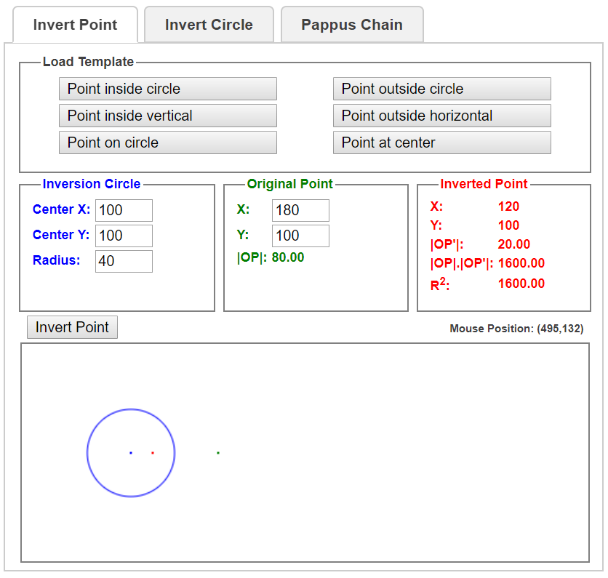

## Inversion of a Circle

The user can load a template with predefined settings with the click of a button, or enter their custom settings and click the “Invert” button to examine the inversion of a circle.

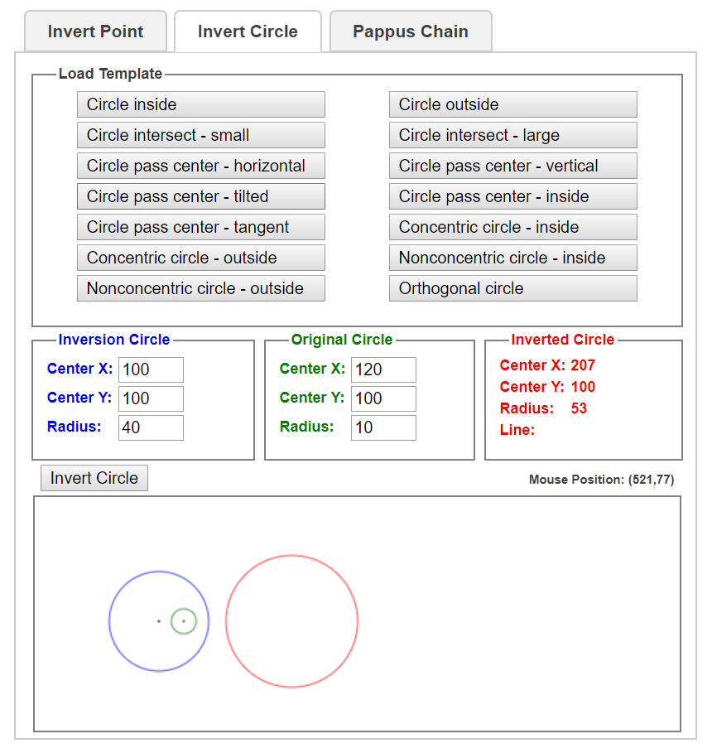

## Pappus Chain

The user can load a template with predefined settings with the click of a button, or enter their custom settings and click the “Create”, “Invert”, or “Homothety” button to examine the Pappus chain.

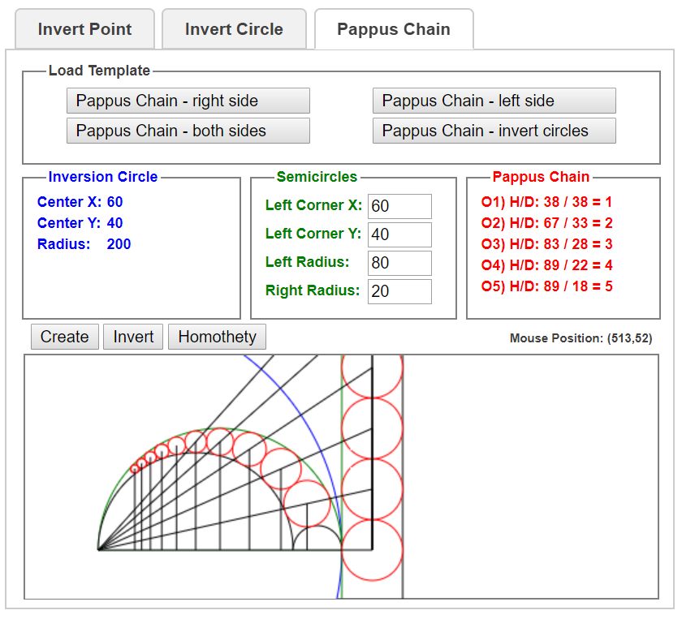

# Discussion

The circles in every inverse pair are homothetic with the center of homothety at the center of inversion. Connecting the center of homothety to the center of original and inverted circles will create similar triangles as shown below.

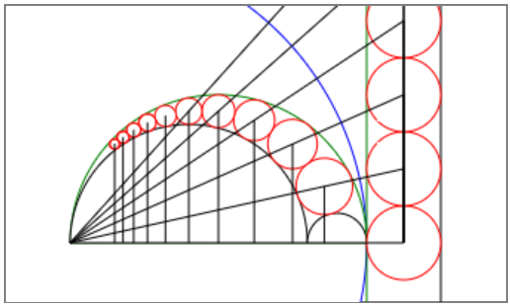

Let *hn* and *h'n*be the height from the centers of circle *n* and its inverse circle, and let *dn* and *d'n*be the diameters of circle *n* and its inverse circle, respectively. Since the circles between the vertical lines are identical, we can easily observe that:

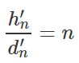

From similarity:

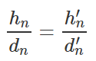

Therefore:

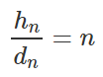

or



This simply proves Pappus’ theorem, which states that the height, *hn*, from the center of the *nth* inscribed circle, *On,* above the diameters of the semicircles is equal to *n* times the diameter of *On*, *dn*.

# Conclusion

Circle inversion can be used to prove a complex theorem such as Pappus chain by visually showing similarity between circles and their inverted images. However, it may not be trivial to see the inversion without proper drawings and calculations.

Since it wasn’t very practical to draw circles with various sizes and calculate their inversions on paper, I decided to develop a computer program with graphics features to draw basic shapes such as points, lines, and circles. This program let me simulate circle inversion and Pappus chain visually, while also showing the calculations.

First, I considered developing a Java program, but I quickly shifted my focus to website development for other people to use it as a tool for further research. Even though a Java program could be turned into a Java applet to run on a web page, I faced security issues on several websites running applets. Besides, it would be harder to host my server code freely, and share the source code with others easily.

Because of the limitations of the server-side coding, I decided to develop a web page in HTML and JavaScript with client-side coding. It runs in the latest browsers on all computers and mobile devices. It was also easy to have a single web page hosted for free.

I share this software application as an open-source tool with anyone interested in math, and specifically in circle inversion and Pappus chain. Please feel free to use the application and get the source code from my web page at <http://sukarablog.weebly.com>.

# Further Research

This project builds the basis for inverting a point or circle with respect to an inversion circle. However, it can be extended to the inversion of other shapes to analyze the effects of circle inversion. It can also be improved to invert shapes and objects with respect to a sphere in 3-D since most of the equations will be very similar to 2-D.

# Acknowledgements

I’d like to thank *Mr. Wenk*, my advisor and geometry teacher, for reviewing my work. I appreciate *Brackets*, an open-source project for a powerful text editor, which I used to type my source code. I also thank *weebly* for hosting my web page for free and making this tool available to others. Finally, I thank *HostMath* for their equation editor that I used to convert equations into nice images before inserting into this report.

# References

AmBrSoft, 2016, <http://www.ambrsoft.com/TrigoCalc/Circles2/circle2intersection/CircleCircleIntersection.htm>

Charles, R. I., Hall, B., and Kennedy, D., 2015, Geometry Common Core, Pearson, 587-593

CutTheKnot, 2017, <https://www.cut-the-knot.org/Curriculum/Geometry/InversionInArbelos.shtml>

EncyclopediaOfMath, 2014, <https://www.encyclopediaofmath.org/index.php/Homothety>

Martin Ivanov, 2017, <http://experiments.wemakesites.net/css3-tabstrip.html>

ScienceBuddies, 2017, <https://www.sciencebuddies.org/science-fair-projects/project-ideas/Math_p011/pure-mathematics/chain-reaction-inversion-pappus-chain-theorem>

Tom Davis, 2011, <http://www.geometer.org/mathcircles/inversion.pdf>

W3Schools, 2017, <https://www.w3schools.com/tags/ref_canvas.asp>

WolframMathWorld, 2017, <http://mathworld.wolfram.com/Inversion.html>